1. – Discussion

Contents

1.1 Description of the Problem 2

Contacts 2

1.2 Broad Aims of the Planned Solution 3

1.3 Limitations of the Planned Solution 4

1.4 Consideration of Feedback 5

1.5 Revised Broad Aims 6

# Description of the Problem

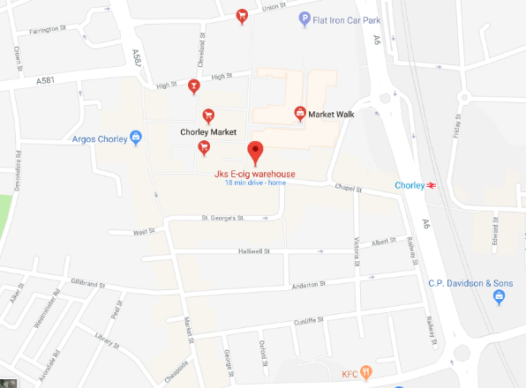The Company that I am doing this program for is: JKs E-Cig warehouse. This company is owned by my grandad and my uncles, when they first started they had one shop in market place Chorley, now they have: 6 shops. One at Atherton, one at Bootle, one at Crosby, one at Chorley, one at Preston and one at Southport. This company sells E-cigarettes and e-liquids. Over the summer holidays I did work at this shop. I packed up the boxes for the e-liquids. I did thousands of them. And I also helped do the stock takes and orders for the other shops. The stock take is such a long time and orders are not pleasant to do either. The company has been around for 7 years. Between the 6 shops they have 19 staff.

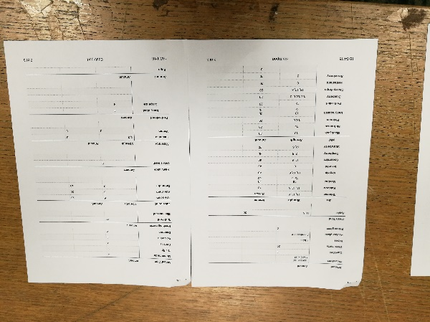The company is open from Monday to Saturday from 8:00AM until 5:00PM and on Sunday from 10:00AM until 4:00PM. The shop that I worked at and the one I will be doing my investigation at is the Chorley market place at 31 Chapel St, Chorley PR7 1BU. I am not aware of any planned expansion. The main problem area is the stock take system, which at the moment is writing stock they have on a piece of paper and this is then handed to the boss after the stocktake is done. Another problem is the clock in clock out system. Which is where they ask around the shops and ask which staff have been in which days. This is the problem area.

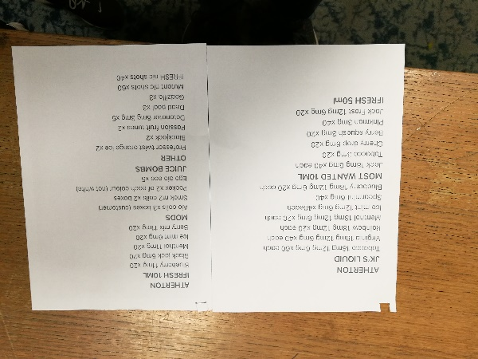The problem is that their outdated system over the stock take and the orders are not very well handled. There are inconsistencies among the orders, which causes confusion between staff and makes orders much harder to do than they should be. whilst I was there I saw more than two different ways that the shops sent their orders. here is a picture of two:

This is a problem across all of their shops and it needs to be resolved. The new system is needed as the old one is not very efficient at all and is a pain to use. All the orders are emailed to the boss and then he prints out the order and gives it to the staff who pack the boxes with the items that the other shops need if they have it.

The problem is an issue for all of their shops as each shop has to count stock and also keep track of the staffs hours, which can be frustrating as the staff have to phone the other shops and ask them how many hours staff have worked. The new system is needed as it is taking more time than it should to do these tasks within the shops. Taking inventory of stock should not take half of the day; orders shouldn’t require other shops to email lists of stock to the manager, these two things alone take up time in all of the shops, if this time could be reduced then the staff could take more time doing other things like cleaning the shop.

The Email system isn’t that efficient as even though it provides a crude way to track what stock has been ordered from each shop. I want to make my system combat these issues and make it easier for the staff to do stock and orders by also adding a stock ordering system that has two ends. Ordering stock, which will be mainly manual (adding stock into the order by hand), it will work alongside stock warnings and when there is a stock warning it will ask whether the employee would want to order the stock for next delivery, the employee will be able to choose which stock to order from a menu.

The old system makes staff work slower and also causes frustration, which could lead to loss of customers (if the staff are annoyed) The current order system isn’t very good as it is a sticky note that is placed onto the product and then the product is put into the back room. While it is there the sticky note can fall off. This can cause confusion amongst staff as to what exactly was wrong with the product. I will to make an easy to use returns area of the program, which allows the staff to enter info into the system such as details of the problem with the product and how long ago the customer bought the product. I will gain feedback from the system by asking the employees questions about the system after they have used it for a while, I will ask them when they are not busy.

--------for each problem area - why is a pain and what can be done to fix it

## Contacts

* Mr J Jones <Boss>(Chorley)
* Mr K Jones <Boss>(Chorley)
* Mr S Jones <Boss>(Chorley)
* Mr C Jones <Employee>(Chorley)
* Mr T Mckenzie <Employee>(Chorley)

# Broad Aims of the Planned Solution

Access Levels and Login

In order to keep the system running smoothly and keep the data safe, the system will implement user access levels, which will only allow users with certain permissions to do certain things within the program. For example, if you are an admin you can change staff’s information, which a normal staff member wont be able to do.

To Make the system work as well as it can, and not waste valuable work time, I will make the system easy to log into and out of. This will make the staff be able to carry out tasks on the system quickly and effectively. The log in and log out system will also help to keep data safe, as each user account will have a number passcode. This will stop unauthorised access to the system.

To make the staff work at peak efficiency and not get distracted by the GUI of the program, the program will only allow staff that should be able to see certain data to view it, this means that the GUI won’t be cluttered by data that the staff member shouldn’t or doesn’t need to see.

To make issues easier to solve, so that issues can still be fixed when the boss isn’t at the shop, I am going to add a one time use admin account, the password will be reset to a random one each time it is logged into and it will allow the staff to fix problems with the program when there isn’t an admin around. This will have an auto resetting password, of similar strength to a wireless access point password, and each time the account is logged into it will generate a new password and email the admins the password and what was done within the program with the account (a log) of actions.

Stock Control

To make the orders in the shop easier to do, I will make the program handle stock orders from other shops and this will make the jobs of staff having to deal with orders much easier.

To make the stock easier to control and count, I will make it really easy to add stock to the system, this will make the staff more inclined to use the system that I am putting in place as it will make their job easier.

I will also make it really easy to delete stock that isn’t going to go back in stock. This will be done so that the stock is only removed when the count of stock reaches zero and it has been marked for delete.

I will make it really easy and quick to edit the details of stock in the shop, this will make staff add changes to the stock as soon as the change is made, this will allow the program to be more up to date, which allows it to have more info on what is going on in the shop.

To make the handling of returns easy to do, the program will have an easy to use interface with a variety of options to pick from and input data into . I aim to make the returns able to be done with just a few button taps. For this I will need to use buttons with reasons for the return on and this will auto fill in the information.

Clocking In

To make staff wages easier to calculate, I will make the system calculate the amount of hours that each member of staff has worked on a particular week and also calculate the amount of hours that members of staff have worked per day as well.

To make sure that staff are going to work when they should be, the program will recognise patterns in days off for staff and notify the boss via email if a pattern is detected. The program will also tell the boss if staff have not clocked in at the start of the day or if they haven’t clocked back in after lunch.

To make the staff hours easier to log and view, I am going to add an easy to view list of staff currently clocked in and also a table showing the weekly hours of staff through the current week against how many hours they should have worked.

To make the staff wages easier to calculate I am going to make the list of staff hours printable, so that after a week the program will send an email to the boss containing a printable document, which contains a list of staff hours, that can then be given to the accountant to calculate staff wages. This will make the bosses job easier as he won`t have to phone around the shops to get staffs wages

Interface

To make the program easy and quick to use I will add an easy to use graphical user interface, this will help the staff to become more efficient and make the shop run more effectively, meaning that more work will get done within the shop.

To make the program less distracting to staff during work hours, I will make the program have a very minimalistic design, this will stop the staff from being distracted when they are supposed to be working, meaning that more work will get done within the work day.

To make the program easy to navigate and get information from, I will make the program have a clean and easy to understand interface. This will also not distract staff from their work and this also means that they will get more done in a work day.

To make the program easier to manage, I will make the program send an email to the boss every week telling him any changes that have been made to the system during the week and who made the changes to the system.

Security

To make the data more secure I will implement Encryption within the program, this will make staff and customers data secure, which will not enable data to be easily stolen. In addition to this it will satisfy the data protection act.

To make the program more secure, I will implement a log of things that have been done, this will only be able to be viewed by an admin and only be able to be deleted by an admin. A copy of this log will be emailed to itself, so that even when the logs are removed from the hardware, a copy will be saved onto its email address.

Audience and purpose.

The software is aimed at the staff, so I want to add some info to the ui that would be useful to the staff. I am going to sparingly add colours from the company logo to the program and I will of course add the end users preferences when it comes to colours. I will add try to add backups to the system. I will have to research how to efficiently back up and what times I should do it.

I will need to make the user interface easy and quick to use, I am going to design it in this way as the staff does have a know-how of how to use technology and I am going to make it easy for them to use so that they can get their job done a lot quicker. I will have to make the program look really professional so that it looks smart and gives a good impression of the company to whoever sees it. This may make the staff more inclined to use it.

I want to add user access levels to enable different staff to see different parts of the program and do different things. For example. The boss will be able to see what stock is in each shop, the clock in clock out times and also the overall work times for each staff. While employees will only be able to see the stock in each shop. This will stop employees from seeing information that they shouldn’t.

I want the system to last for as long as the company needs it to last, and for it to be reliable and easy to use

# Limitations of the Planned Solution

* One feature that I have considered but I will not include is Synchronisation between the shops. The reason why I am not going to include this in the final program is that I don’t think that I have the skill level in order to make this feature work, as it would require using a web server, which I would love to be able to create but I don’t think I can. Also this would not be able to be tested at college as the college network blocks a lot of network related things including auto sending emails and web server communication. Also I don’t think that I will be able to do this within the time frame that we have for making the software
* One feature that I have considered but I will not be including is the integration of web to allow the user to see through the program the trending products. This would make a great addition to the program, it would look at the internet and it would look for possible stock. However it requires a skill level that is higher than my own and it will also require more time to learn and implement that I have too. In addition to this I will not be able to test it in college as the network blocks a lot of web related things. Also web pages change a lot over time, which means I will constantly have to update the program in order to get it working effectively.
* I will not be able to add website integration with their own website for internet orders, this would be a great feature and would allow easy managing of internet orders than that of their current system, and it would allow stock to be reserved, so that it is not sold after someone has already bought it. I am not going to be able to do this as I am not at the skill level that is required to do this and also I do not think that I will have the time to add this feature to my program.
* I will not be able to add ePos integration to my program. Adding this would allow the program to gain information from ePos (the till system) and would allow my program to keep up to date with what products are in the shop at any given moment. Without this the program will only get updated when the staff input data into the system (which will be every time they do a stock take), with this information the program would be able to compare the stock take results with the current product numbers. I will not be able to add this feature as I do not have the technical knowhow or the time to do this. In addition, I will not be able to test this in college as the college network blocks a lot of network related things that java uses; for example the college network bans javamail.
* I will not be able to make an accompanying android app for the program. Adding this would allow the staff to easily update details and check on the program from their phone. This would be good as it would allow staff to change and add stock and do tasks on the system when they don’t have access to the computer that it is running on, it would also allow multiple staff to use the system at the same time. I will not be able to do this as I don’t think I will have time to learn android studio and also the IOS equivalent to android studio. Also I think that making an app to run alongside the system is a little bit too complex to program.
* I will not be able to add automatic order tracking. Adding this would allow orders that are asked for to be added and sent between shop systems automatically. Instead I am going to make the stock added manually. I am not going to make stock transfer automatic as I think that I wouldn’t have enough time to do it. Also I won`t be able to test it in college due to network capabilities.

# Consideration of Feedback

|  |  |  |  |
| --- | --- | --- | --- |
| Feedback | From | Accept/Reject | Action to be taken (including Justification) |
| Add user access levels to prevent employees ability to extend their own lunch | Sam Keane | Accept | I will implement this into the program, I was already thinking about it and I just didn’t mention it in my presentation |
| Make the program run on most hardware | Nathan Aspinall | Accept | I will try to make my program as least demanding as I can, this will make it so that it runs well on most hardware |
| Is the stock take table(package) sent by email or physically by the driver | Nathan Aspinall | Accept | The stock take table will be sent by email by the program, this will hopefully be received by the program and can be printed off or can be sorted out via the actual program. |
| Include information about the item or just the stock? | Megan A | Accept | The stock-level will have information about the stock numbers, using the stock id, that stock id is then linked to the stock table which will have information about the stock (what coils each product can take and also information on installation of the coils among other things) |
| Reordering low stock should not be automatic. You could compile a list and then prompt the user | Nick Wilkie | Accept | I was going to make it not full automatic, I was going to add a marker to say whether the stock warning reorders the stock. But I was going to make it mainly manual. That is a good idea to compile a list and then prompt the user to let them know that the stock is low |

# Revised Broad Aims

Due to the feedback I am going to make more use of user access levels in the system. This will allow tight control over what happens in the workplace. They will have a greater impact than I was going to make them. I will not only allow certain staff roles to do specific tasks. This will not allow the staff to extend their lunch unless they are a certain access level.

In order to keep the program slightly synchronised I am going to add javamail indefinitely, to enable the ordering system to work as planned. I will have to do more research upon this subject to see if it is possible as the email system may not be very efficient to do.

To ensure that the user doesn’t have to check stock on their own and maybe make a mistake in terms of not realising which stock they need the stock warnings are going to be semi-automated. The system will implement toggleable stock warning levels and if the stock gets to that level then the system will compile a list and notify the user what stock is low and the user can choose which stock to order and which stock they aren’t going to order.

I will need to make the user interface easy to use and efficient, this will increase the workflow of the staff and allow the staff to want to use the system

ALL AIMS:

---- bold revised broard aims

Access Levels and Login

In order to keep the system running smoothly and keep the data safe, the system will implement user access levels, which will only allow users with certain permissions to do certain things within the program. For example, if you are an admin you can change staff’s information, which a normal staff member wont be able to do.

To Make the system work as well as it can, and not waste valuable work time, I will make the system easy to log into and out of. This will make the staff be able to carry out tasks on the system quickly and effectively. The log in and log out system will also help to keep data safe, as each user account will have a number passcode. This will stop unauthorised access to the system.

To make the staff work at peak efficiency and not get distracted by the GUI of the program, the program will only allow staff that should be able to see certain data to view it, this means that the GUI won’t be cluttered by data that the staff member shouldn’t or doesn’t need to see.

To make issues easier to solve, so that issues can still be fixed when the boss isn’t at the shop, I am going to add a one time use admin account, the password will be reset to a random one each time it is logged into and it will allow the staff to fix problems with the program when there isn’t an admin around. This will have an auto resetting password, of similar strength to a wireless access point password, and each time the account is logged into it will generate a new password and email the admins the password and what was done within the program with the account (a log) of actions.

**To ensure staff don’t extend their own lunches, I will make more predominant use of the access levels and only allow certain level of people be able to do certain tasks, such as extending lunches. Only admins will be able to extend lunches and the program will not allow only two people to be left in the shop while the others go on their lunch.**

Stock Control

To make the orders in the shop easier to do, I will make the program handle stock orders from other shops and this will make the jobs of staff having to deal with orders much easier.

To make the stock easier to control and count, I will make it really easy to add stock to the system, this will make the staff more inclined to use the system that I am putting in place as it will make their job easier.

I will also make it really easy to delete stock that isn’t going to go back in stock. This will be done so that the stock is only removed when the count of stock reaches zero and it has been marked for delete.

I will make it really easy and quick to edit the details of stock in the shop, this will make staff add changes to the stock as soon as the change is made, this will allow the program to be more up to date, which allows it to have more info on what is going on in the shop.

To make the handling of returns easy to do, the program will have an easy to use interface with a variety of options to pick from and input data into . I aim to make the returns able to be done with just a few button taps. For this I will need to use buttons with reasons for the return on and this will auto fill in the information.

**To make it easier for shops to manage stock, I will make my system compile a list of low stock and then prompt the staff on whether they want to order the stock. If they do it will add it to a list of the stock that the user is going to order, if not then the list will be deleted and either way the stock to order will be added manually to the list to order**

**Orders will be printed off or sent in a table on a document to the main shop, this will make the orders easier to do and will also make them more consistent**

Clocking In

To make staff wages easier to calculate, I will make the system calculate the amount of hours that each member of staff has worked on a particular week and also calculate the amount of hours that members of staff have worked per day as well.

To make sure that staff are going to work when they should be, the program will recognise patterns in days off for staff and notify the boss via email if a pattern is detected. The program will also tell the boss if staff have not clocked in at the start of the day or if they haven’t clocked back in after lunch.

To make the staff hours easier to log and view, I am going to add an easy to view list of staff currently clocked in and also a table showing the weekly hours of staff through the current week against how many hours they should have worked.

To make the staff wages easier to calculate I am going to make the list of staff hours printable, so that after a week the program will send an email to the boss containing a printable document, which contains a list of staff hours, that can then be given to the accountant to calculate staff wages. This will make the bosses job easier as he won`t have to phone around the shops to get staffs wages

Interface

To make the program easy and quick to use I will add an easy to use graphical user interface, this will help the staff to become more efficient and make the shop run more effectively, meaning that more work will get done within the shop.

To make the program less distracting to staff during work hours, I will make the program have a very minimalistic design, this will stop the staff from being distracted when they are supposed to be working, meaning that more work will get done within the work day.

To make the program easy to navigate and get information from, I will make the program have a clean and easy to understand interface. This will also not distract staff from their work and this also means that they will get more done in a work day.

To make the program easier to manage, I will make the program send an email to the boss every week telling him any changes that have been made to the system during the week and who made the changes to the system.

Security

To make the data more secure I will implement Encryption within the program, this will make staff and customers data secure, which will not enable data to be easily stolen. In addition to this it will satisfy the data protection act.

To make the program more secure, I will implement a log of things that have been done, this will only be able to be viewed by an admin and only be able to be deleted by an admin. A copy of this log will be emailed to itself, so that even when the logs are removed from the hardware, a copy will be saved onto its email address.

**To make the system more secure, I will add password locks or timeouts onto the system, so that the staff are auto signed out after a short amount of time, this way less info can be stolen/maliciously accessed. This will stop staff accidentally forgetting to log out of the system and making the data editable to anyone.**